Test Case: runTestMultipleTimes
Step 1 - Enter username and password and click to button Enter : Credentials Entered
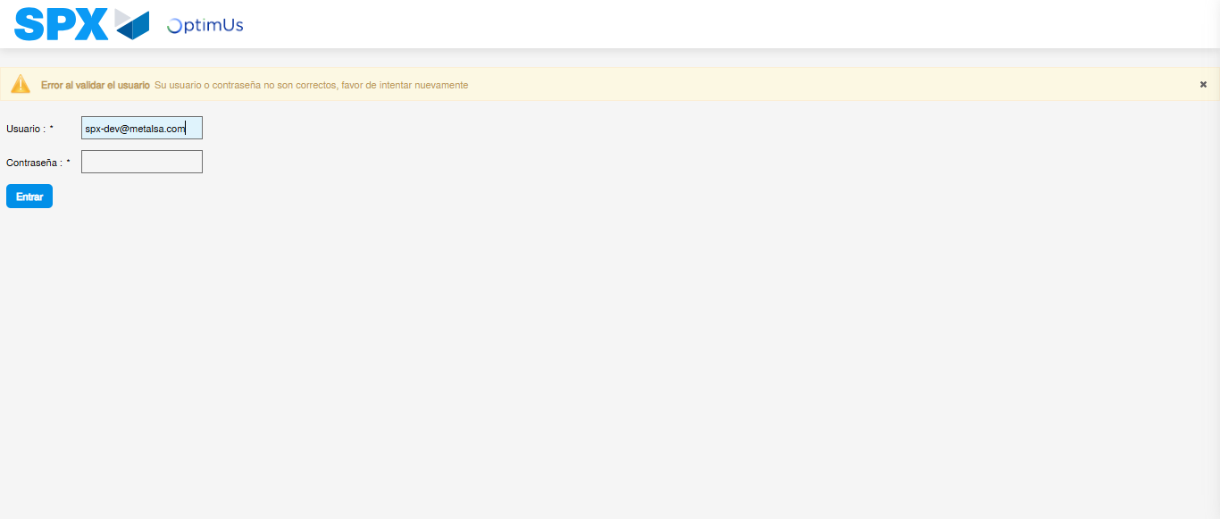Image file-name: QC_Testing-runTestMultipleTimes-nov. 25 2025, 02 06 30 p. m.

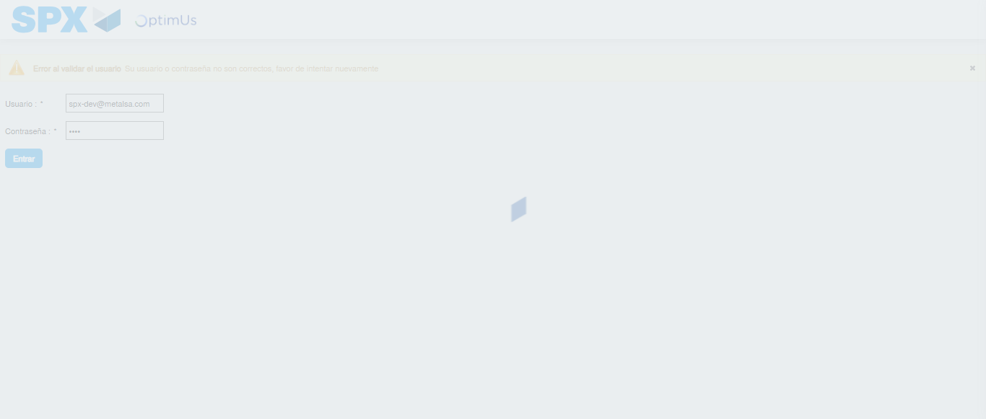Image file-name: QC_Testing-runTestMultipleTimes-nov. 25 2025, 02 06 31 p. m.

Step 2 - Select to UEN and Access to Spot Buy Requisitions : UEN Correctly selected and Correct access
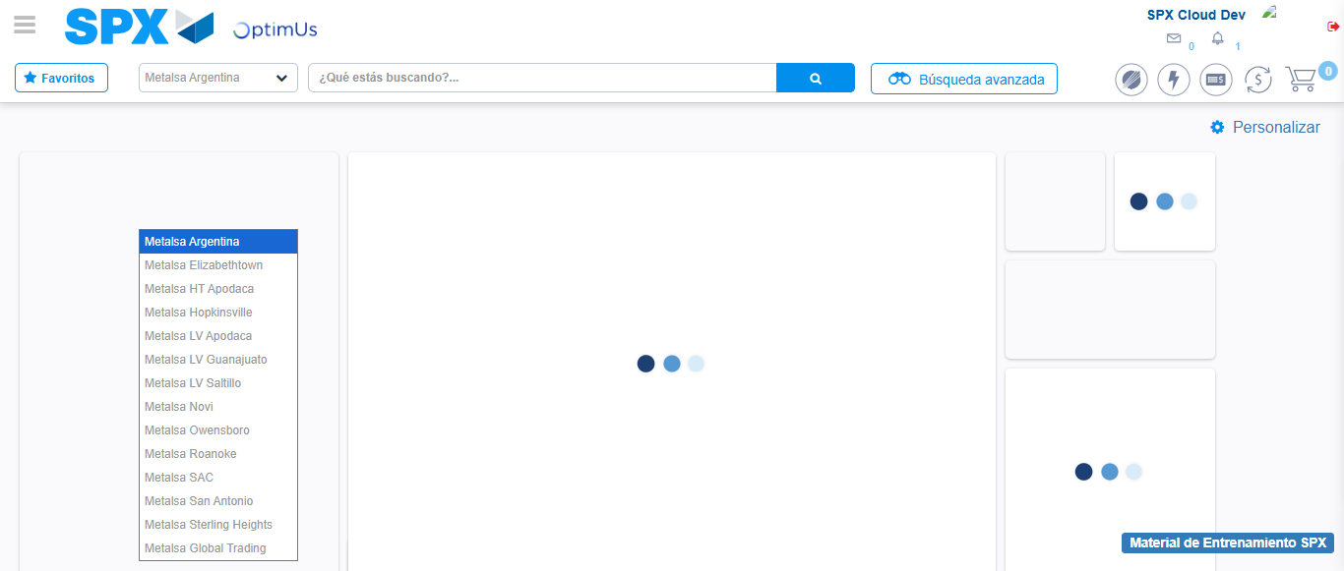Image file-name: QC_Testing-runTestMultipleTimes-nov. 25 2025, 02 06 34 p. m.

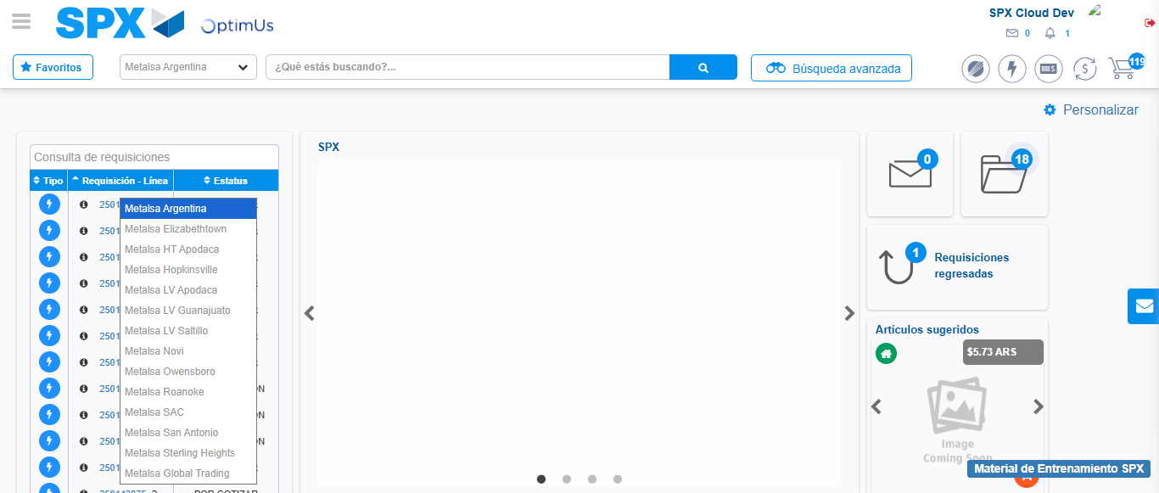Image file-name: QC_Testing-runTestMultipleTimes-nov. 25 2025, 02 06 35 p. m.

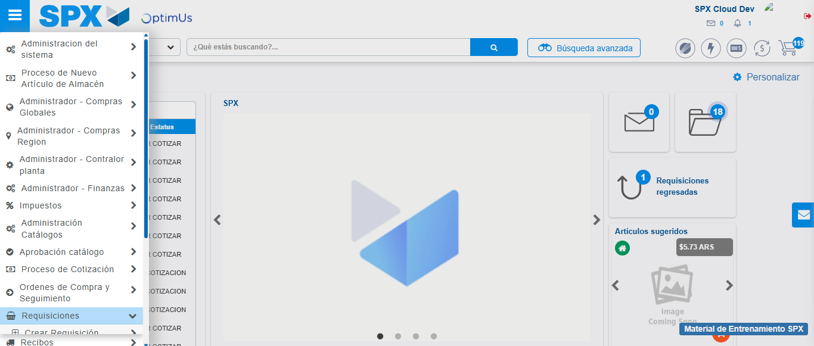Image file-name: QC_Testing-runTestMultipleTimes-nov. 25 2025, 02 06 36 p. m.

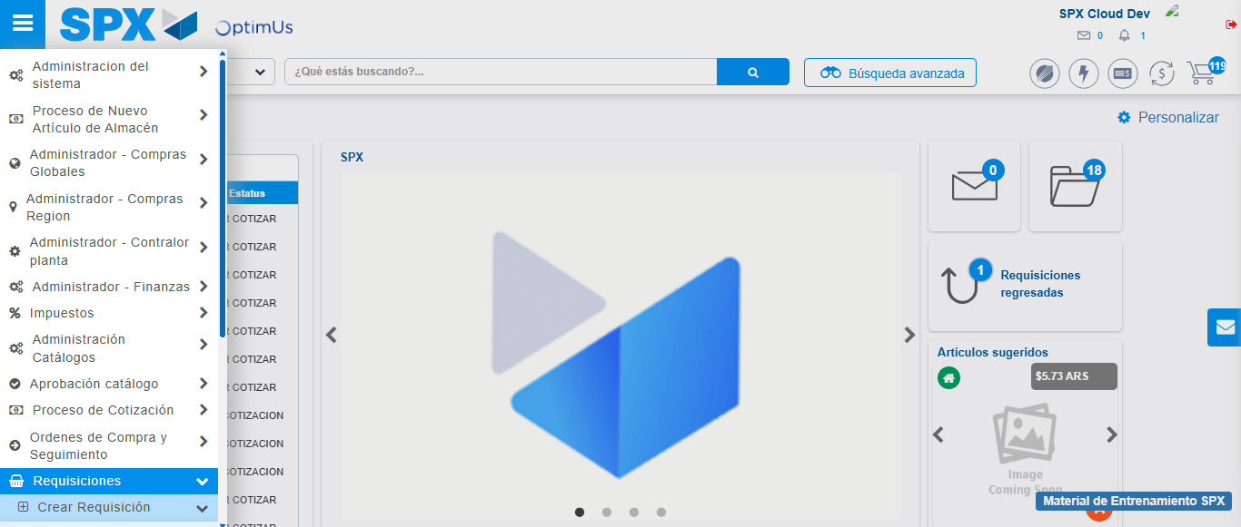Image file-name: QC_Testing-runTestMultipleTimes-nov. 25 2025, 02 06 37 p. m.

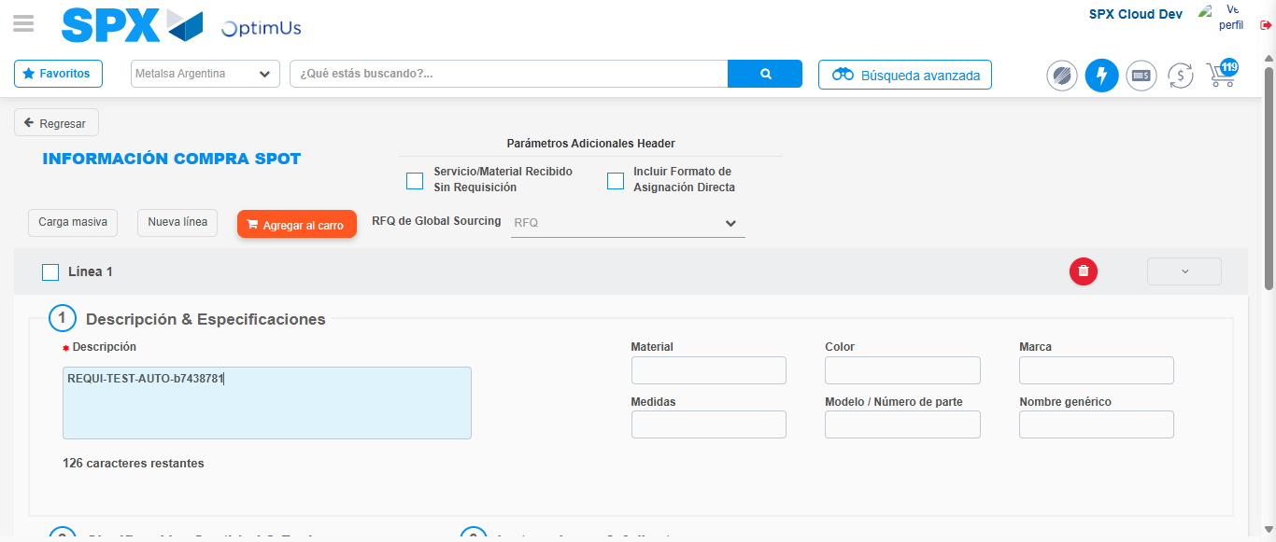Image file-name: QC_Testing-runTestMultipleTimes-nov. 25 2025, 02 06 41 p. m.

Step 3 - Data Capture Spot Buy Requisition : Data captured correctly
Image file-name: QC_Testing-runTestMultipleTimes-nov. 25 2025, 02 06 41 p. m.

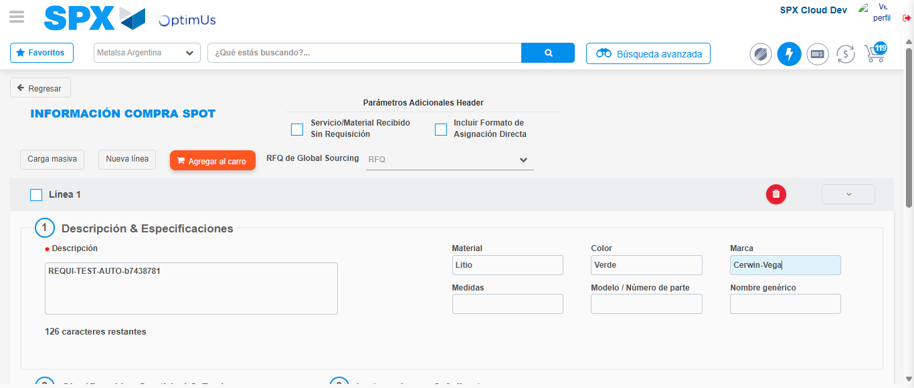Image file-name: QC_Testing-runTestMultipleTimes-nov. 25 2025, 02 06 42 p. m.

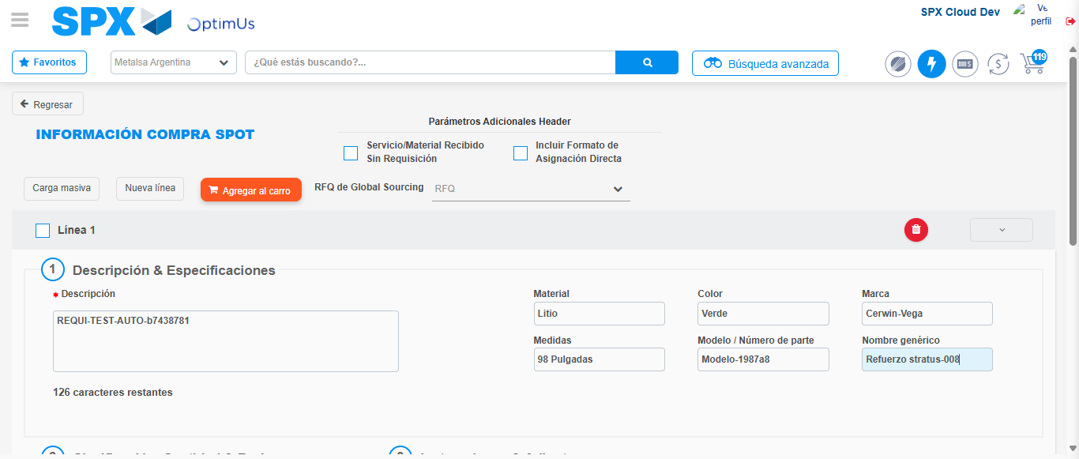Image file-name: QC_Testing-runTestMultipleTimes-nov. 25 2025, 02 06 43 p. m.

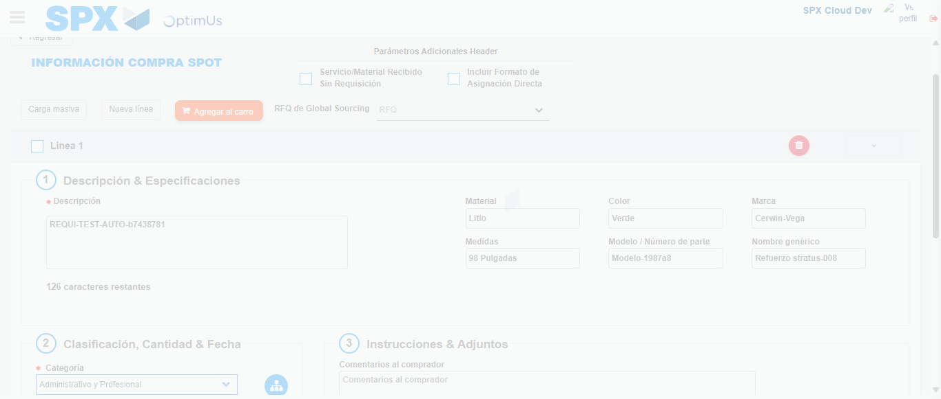Image file-name: QC_Testing-runTestMultipleTimes-nov. 25 2025, 02 06 44 p. m.

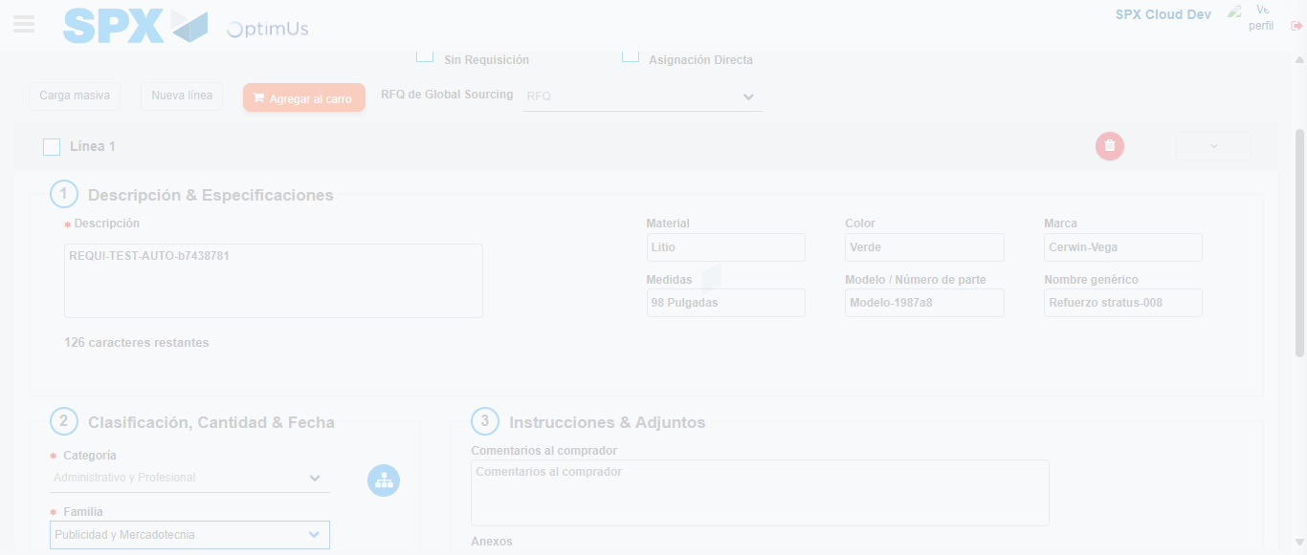Image file-name: QC_Testing-runTestMultipleTimes-nov. 25 2025, 02 06 45 p. m.

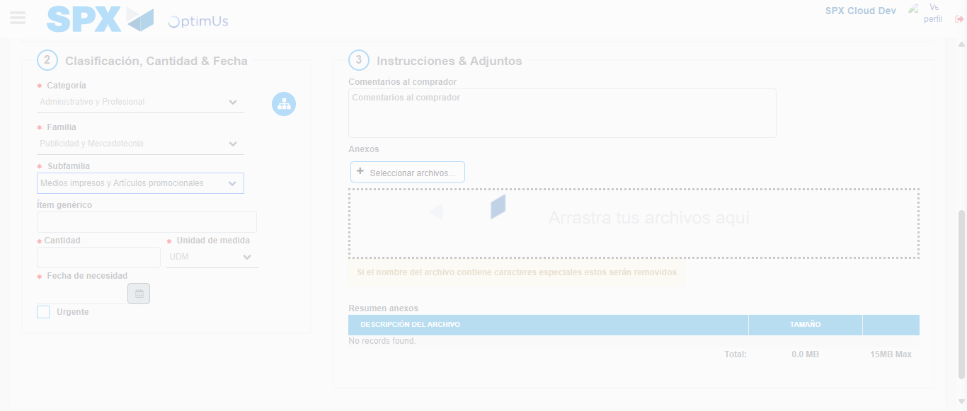Image file-name: QC_Testing-runTestMultipleTimes-nov. 25 2025, 02 06 46 p. m.

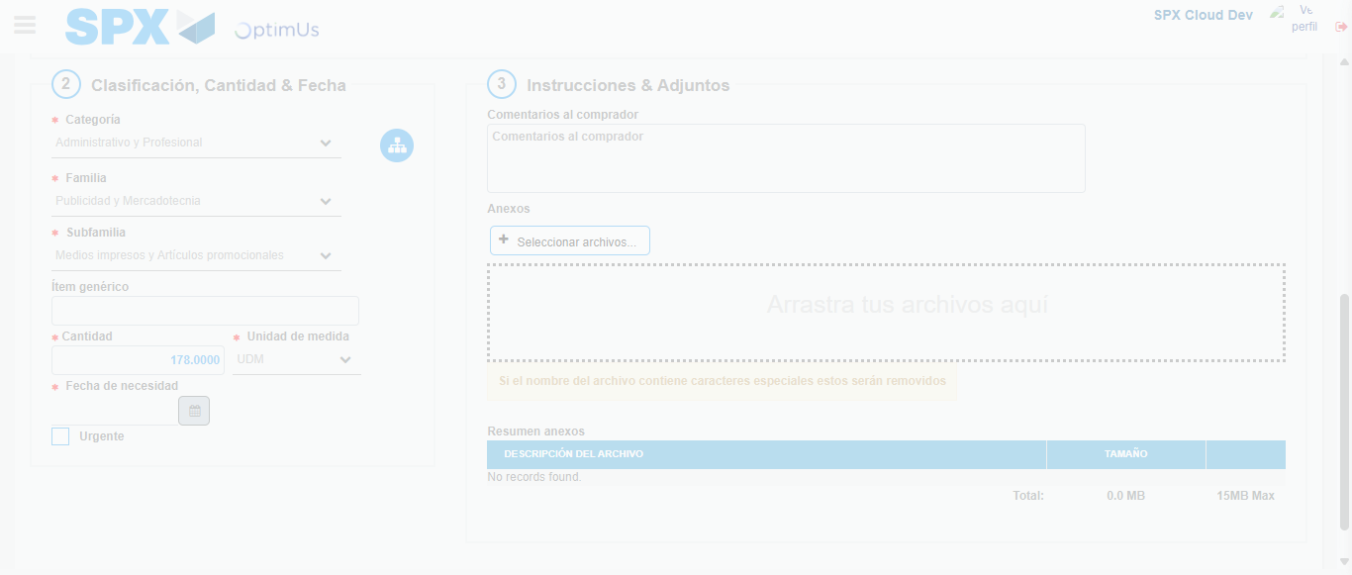Image file-name: QC_Testing-runTestMultipleTimes-nov. 25 2025, 02 06 47 p. m.

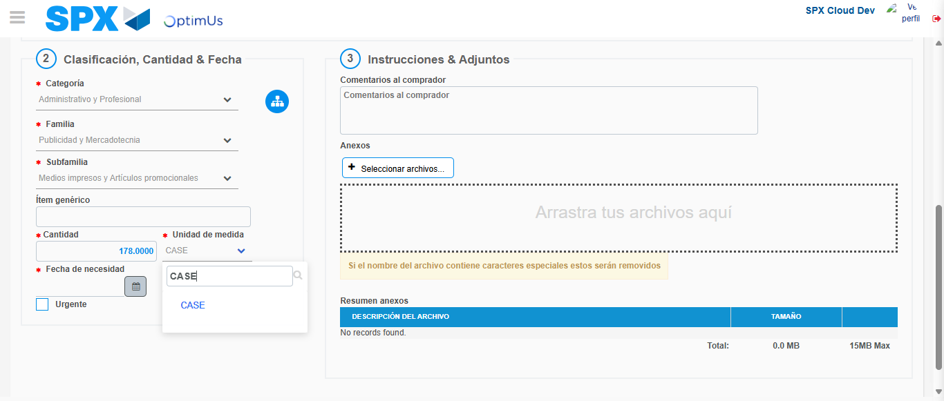Image file-name: QC_Testing-runTestMultipleTimes-nov. 25 2025, 02 06 50 p. m.

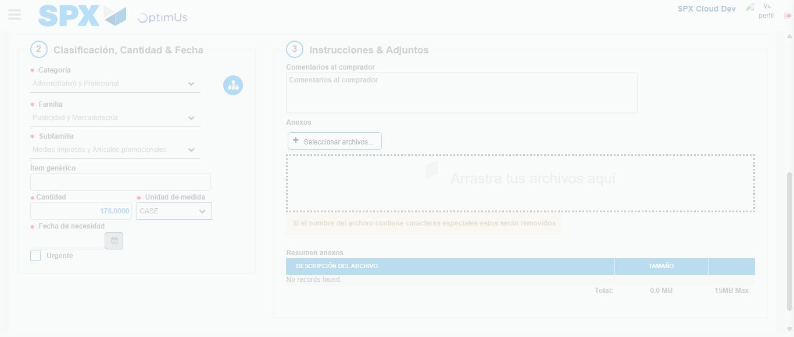Image file-name: QC_Testing-runTestMultipleTimes-nov. 25 2025, 02 06 51 p. m.

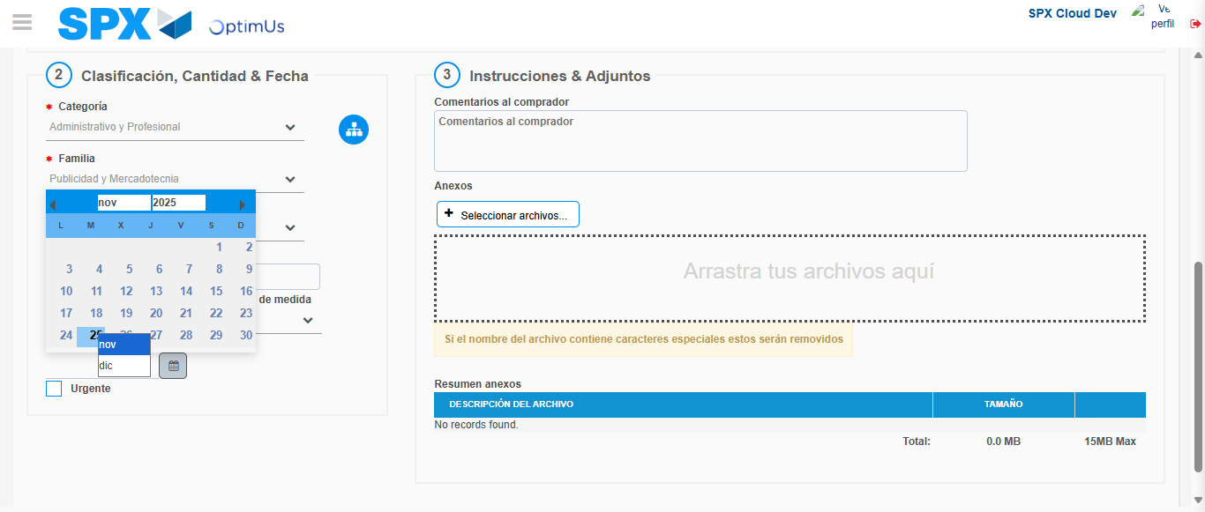Image file-name: QC_Testing-runTestMultipleTimes-nov. 25 2025, 02 06 54 p. m.

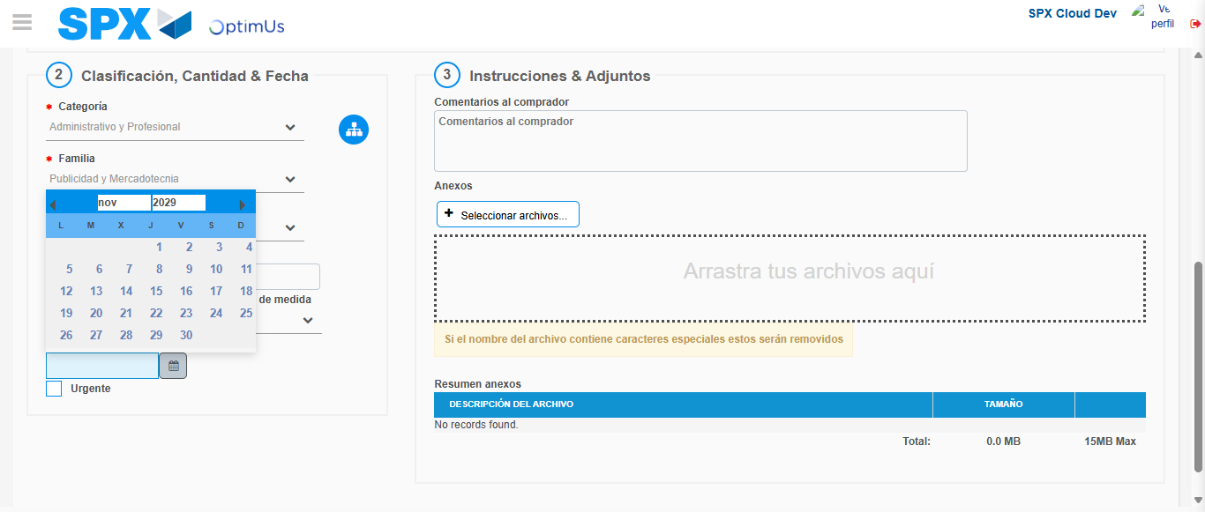Image file-name: QC_Testing-runTestMultipleTimes-nov. 25 2025, 02 06 55 p. m.

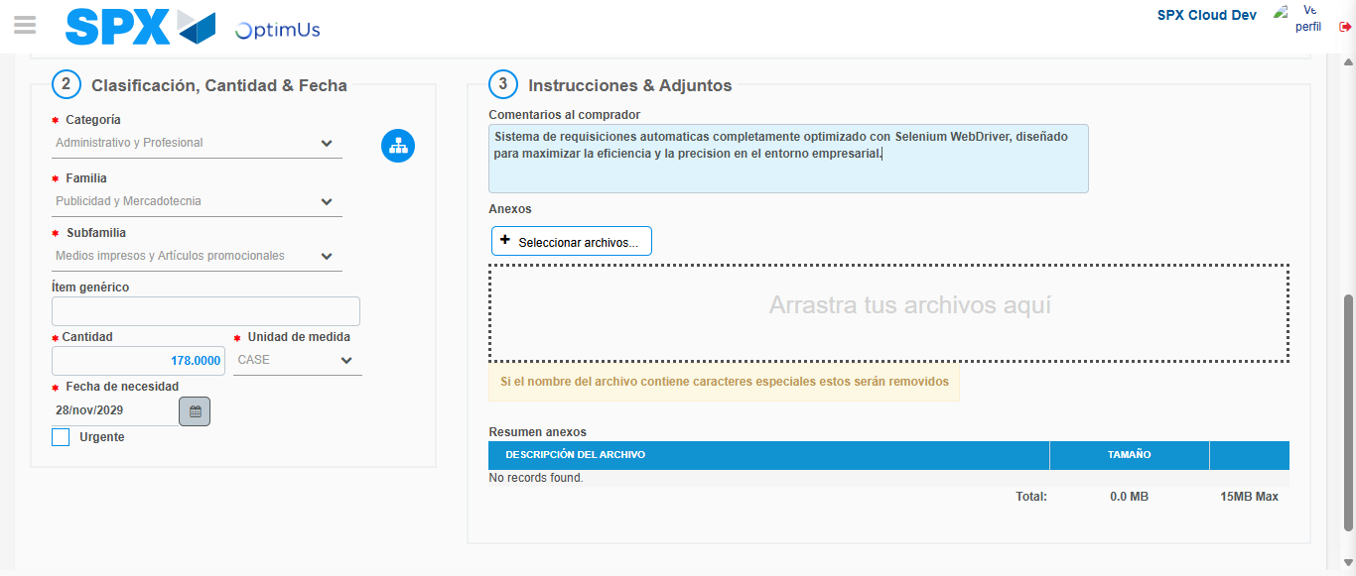Image file-name: QC_Testing-runTestMultipleTimes-nov. 25 2025, 02 06 56 p. m.

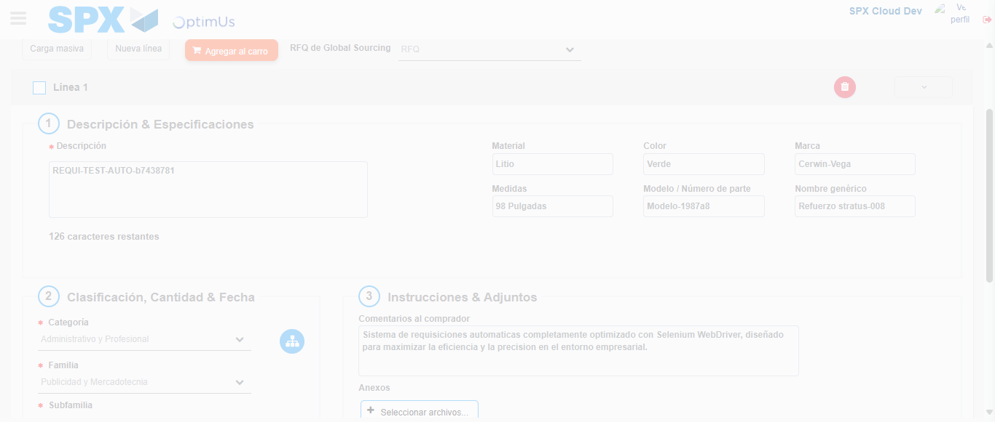Image file-name: QC_Testing-runTestMultipleTimes-nov. 25 2025, 02 06 57 p. m.

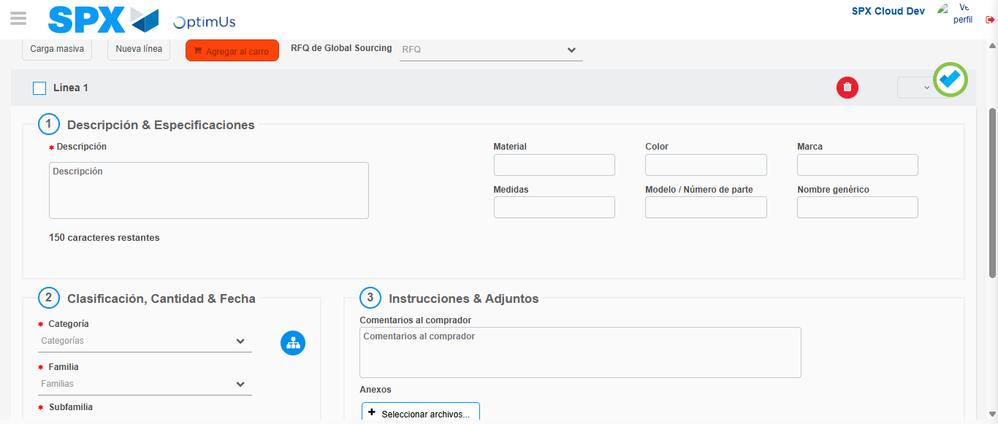Image file-name: QC_Testing-runTestMultipleTimes-nov. 25 2025, 02 07 00 p. m.

Step 4 - Select to Requisition : Requisition Correctly selected
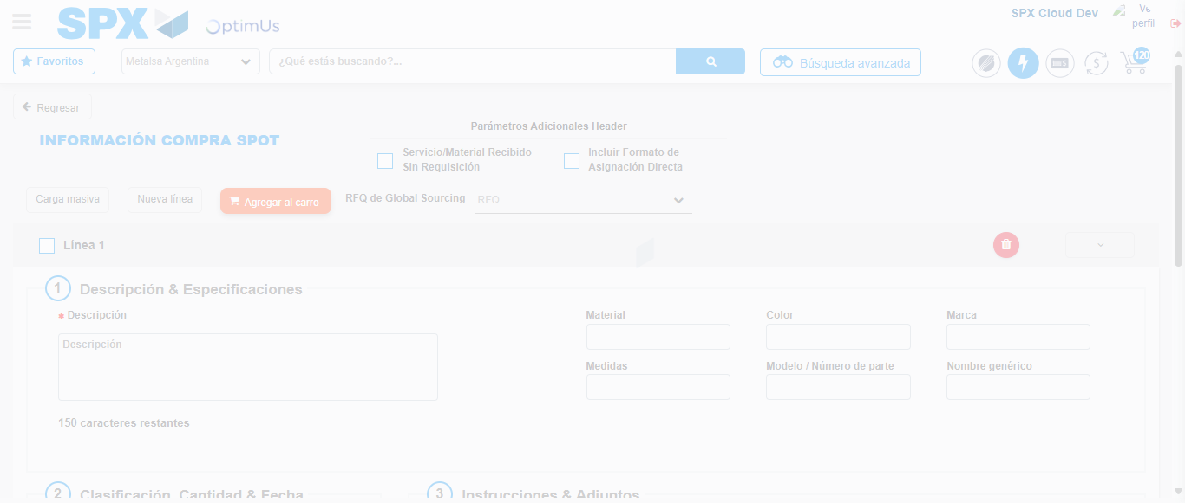Image file-name: QC_Testing-runTestMultipleTimes-nov. 25 2025, 02 07 09 p. m.

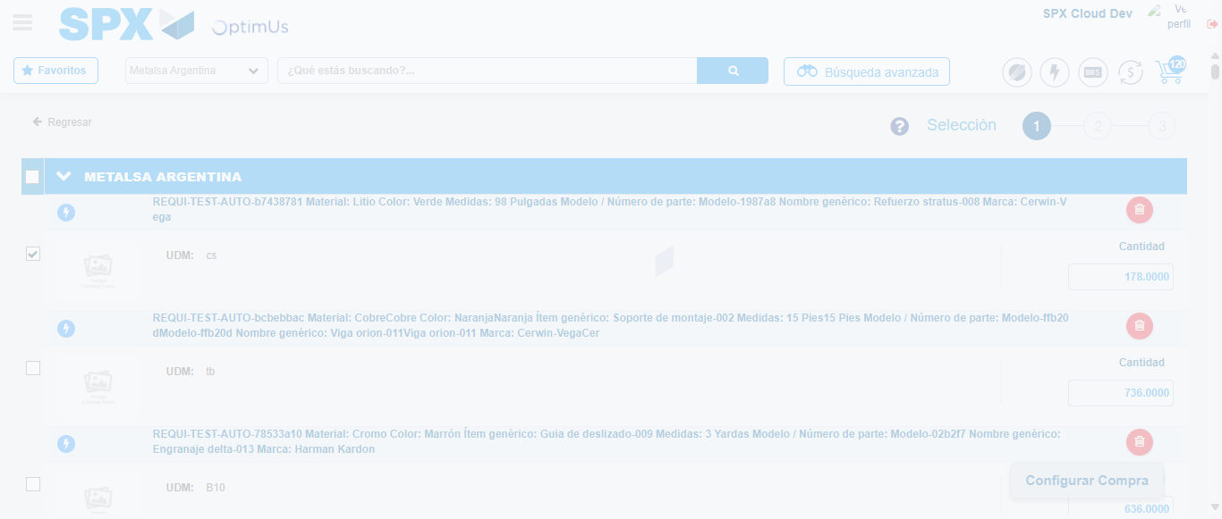Image file-name: QC_Testing-runTestMultipleTimes-nov. 25 2025, 02 07 10 p. m.

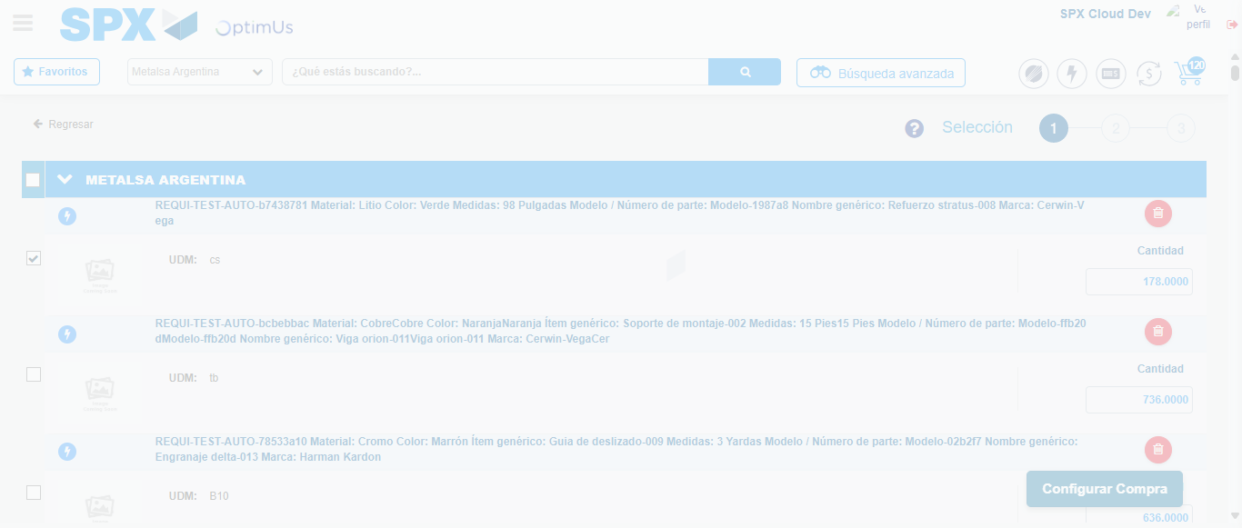Image file-name: QC_Testing-runTestMultipleTimes-nov. 25 2025, 02 07 13 p. m.

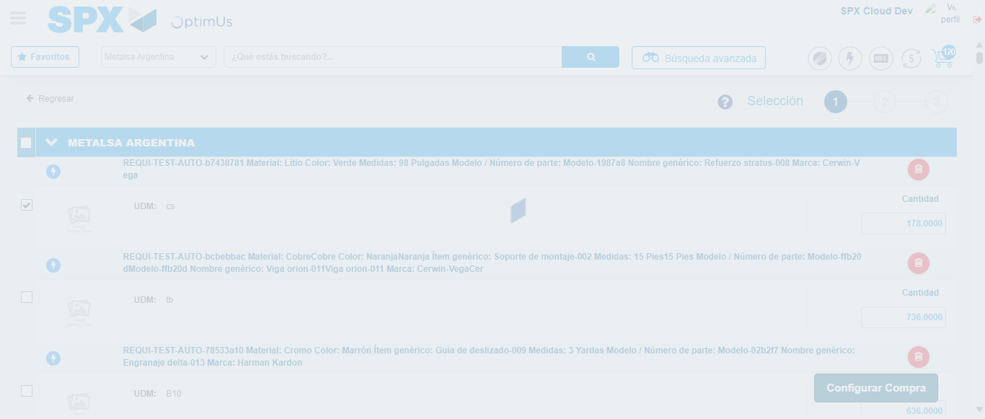Image file-name: QC_Testing-runTestMultipleTimes-nov. 25 2025, 02 07 14 p. m.

Step 5 - Select Type Account For Requisition : Type Account Correctly selected
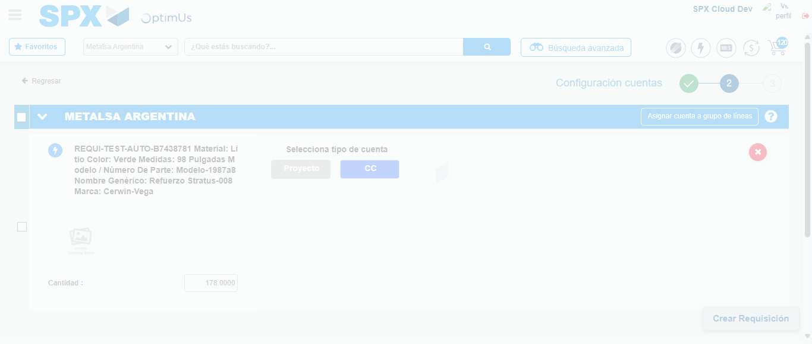Image file-name: QC_Testing-runTestMultipleTimes-nov. 25 2025, 02 07 18 p. m.

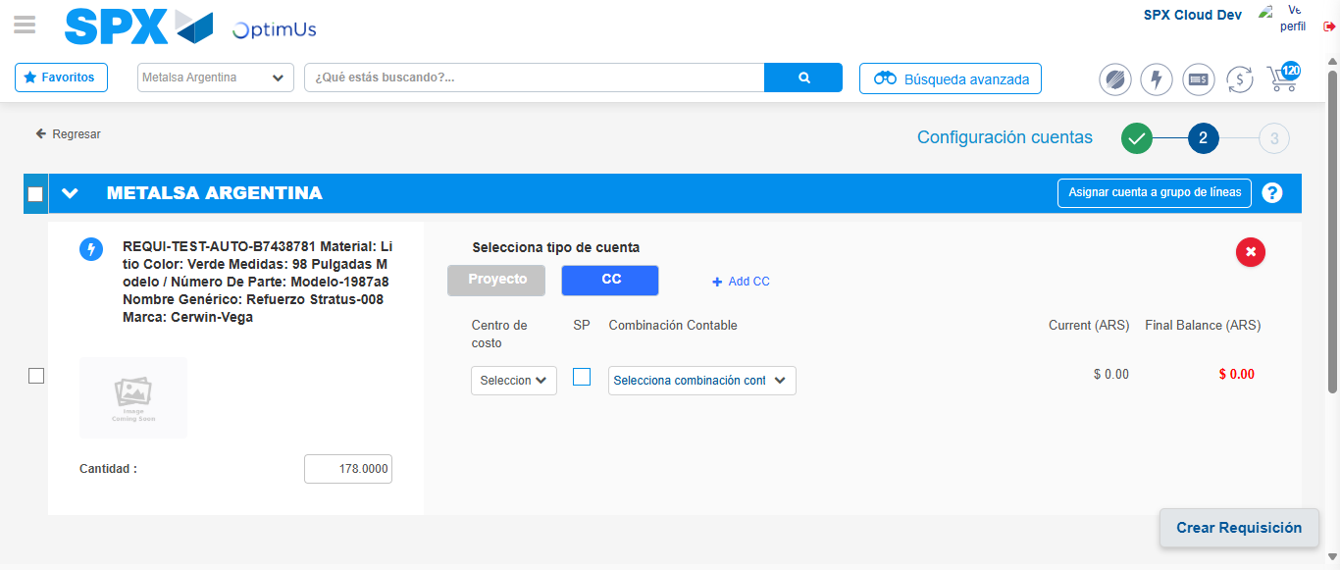Image file-name: QC_Testing-runTestMultipleTimes-nov. 25 2025, 02 07 21 p. m.

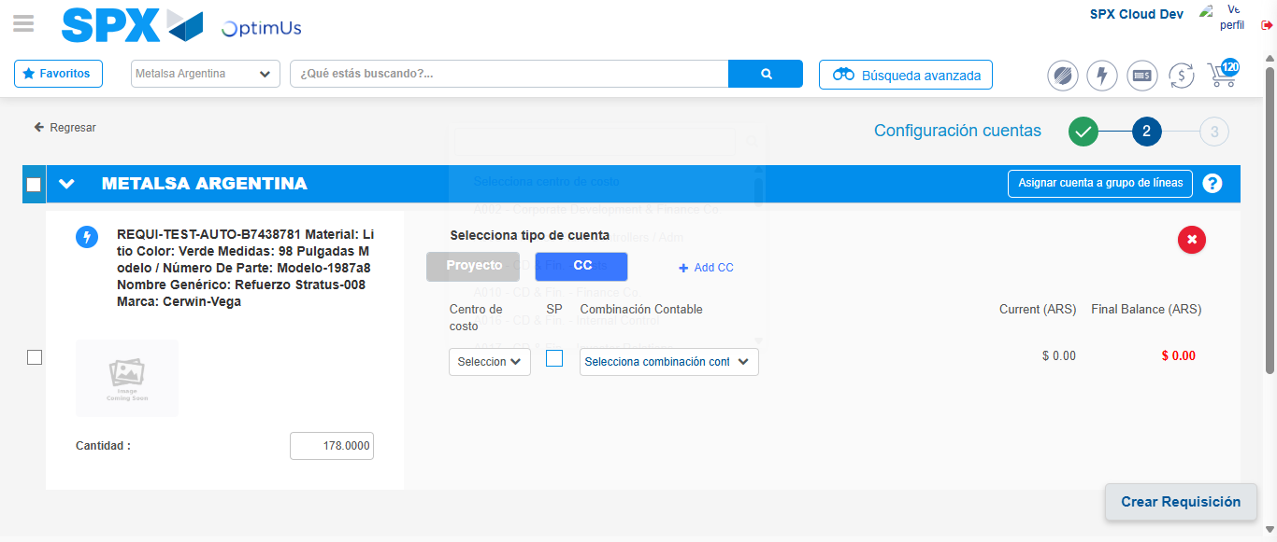Image file-name: QC_Testing-runTestMultipleTimes-nov. 25 2025, 02 07 24 p. m.

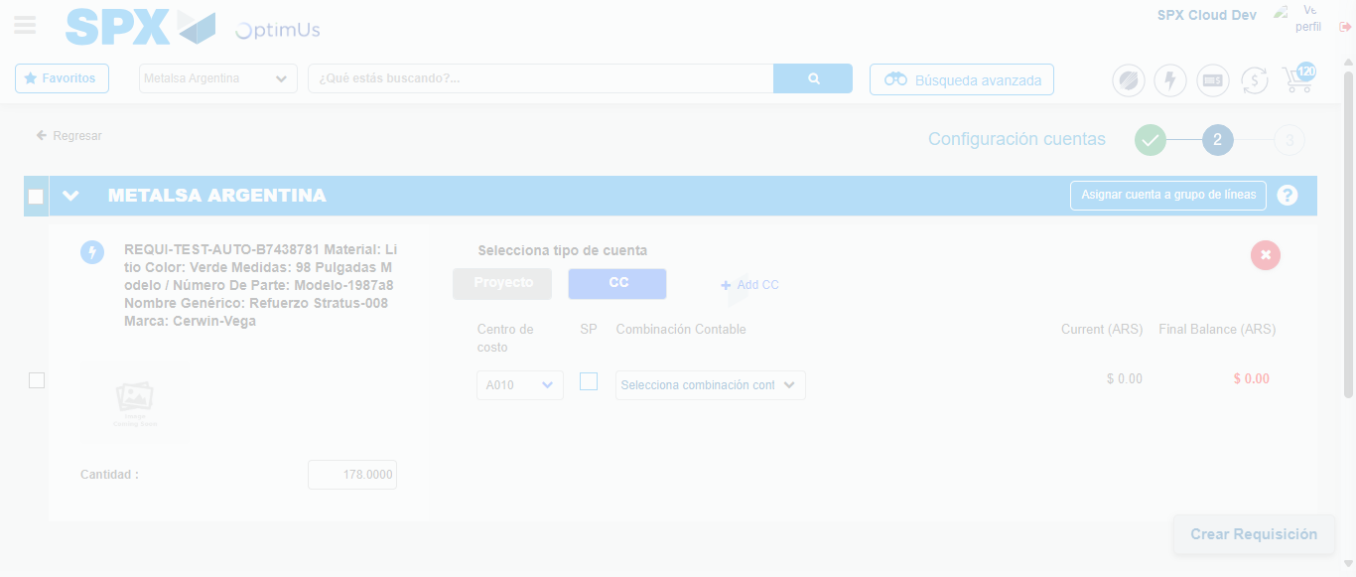Image file-name: QC_Testing-runTestMultipleTimes-nov. 25 2025, 02 07 25 p. m.

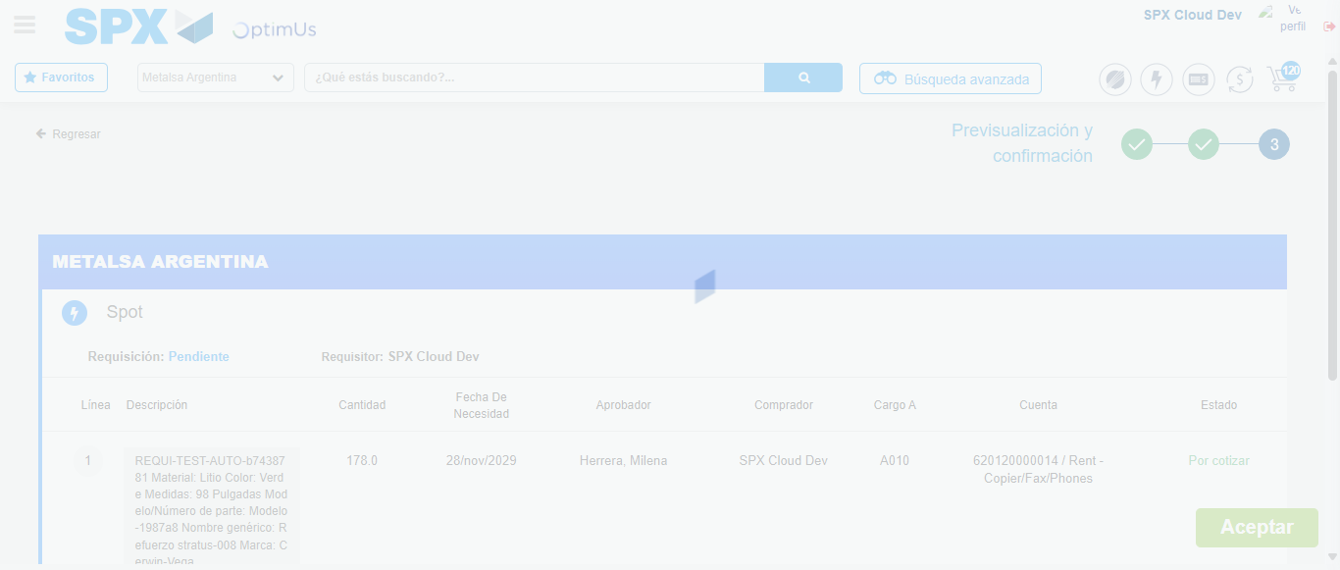Image file-name: QC_Testing-runTestMultipleTimes-nov. 25 2025, 02 07 28 p. m.

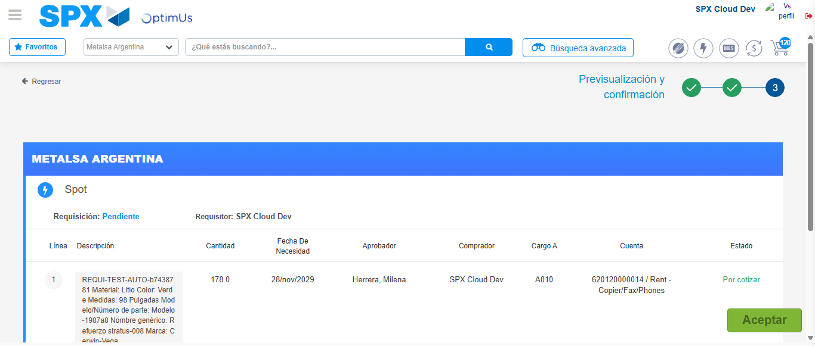Image file-name: QC_Testing-runTestMultipleTimes-nov. 25 2025, 02 07 32 p. m.

Step 6 - Accept to Requisition : Requisition Accepted
Image file-name: QC_Testing-runTestMultipleTimes-nov. 25 2025, 02 07 32 p. m.

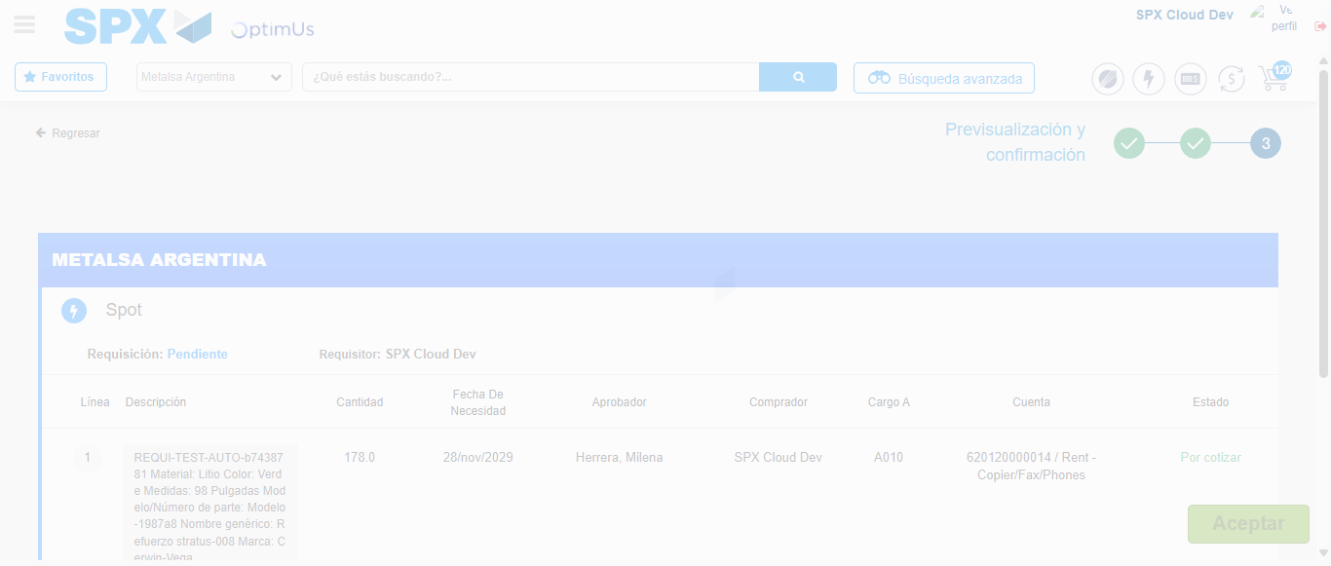Image file-name: QC_Testing-runTestMultipleTimes-nov. 25 2025, 02 07 33 p. m.

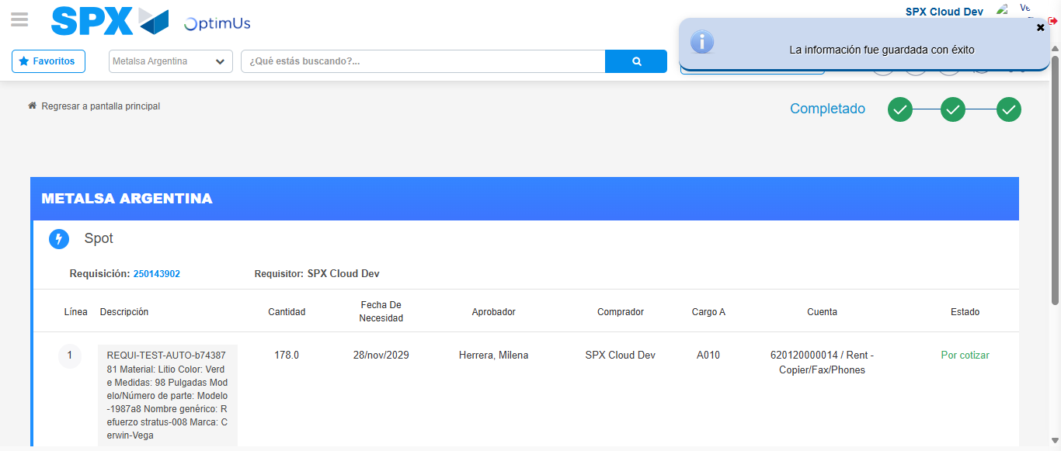Image file-name: QC_Testing-runTestMultipleTimes-nov. 25 2025, 02 07 36 p. m.

